LAKEVIEW

SCHOOL OF NURSING
COLLEGE OF NURSING

ALUMNI NEWSLETTER

JUNE 2024


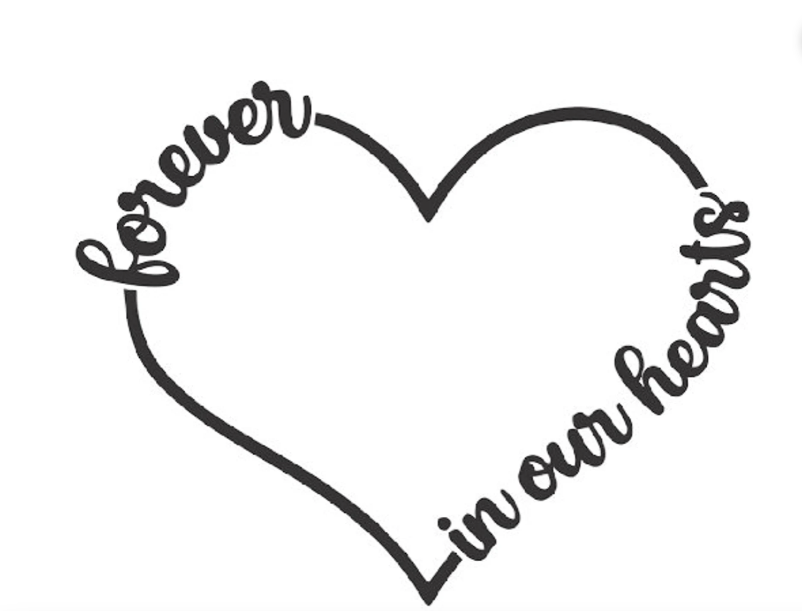

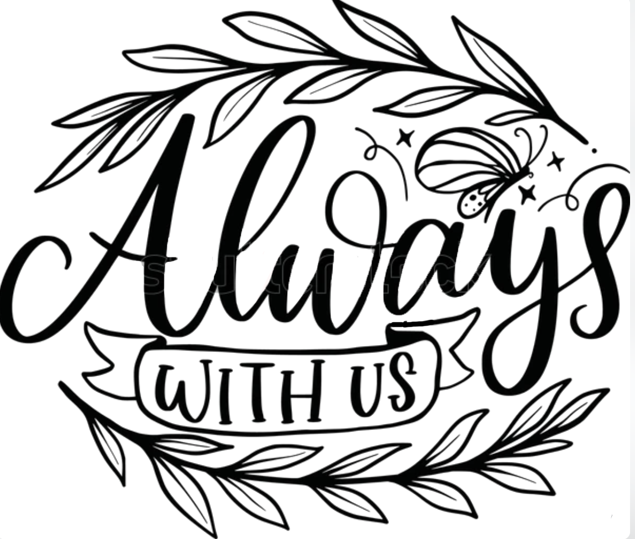
Alumni Deaths

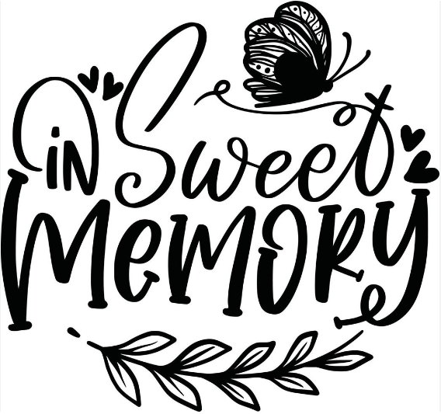
Names of Alumni Deceased Since Last Celebration

Frances Hensrud Burton | Class of: | ‘47
Dorothy Cornett Jones | Class of: | ‘47
Pat McConnell McCay | Class of: | ‘52
Mary Jane Weise Hanson | Class of: | ‘54
Vera Kelly Weaver | Class of: | ‘56
Nancy Sheffield Anderson | Class of: | ‘61
Mary Ann Milliner Williams | Class of: | ‘65
Mary Zumwalt Ewing | Class of: | ‘65
Judy Roderick Winkler | Class of: | ‘66
Annette Okerland Willet | Class of: | ‘75
Marilyn Youngblood Starkey | Class of: | ‘77
Louise Houmes | Class of: | ‘81
Thomasina Withers | Class of: | ‘83
Carolyn Greene Hall | Class of: | ‘84
Donna Dill | Class of: | ‘85

Before I Go

When my life has reached its very end,
And I take that final breath;
I want to know I've left behind,
Some "good" before my death.
I hope that in my final hour,
In all honesty I can say:
That somewhere in my lifetime,
I have brightened someone's day.
That maybe I have brought a smile
To someone else's face,
And made one moment a little sweeter
While they dwelled here in this place.
With all my heart, I truly hope
To leave something here on earth
That touched another, made them smile
And gave to my life, some worth.

2024 - Alumni Association President's comments
We are wrapping up another year for the Lakeview Alumni Association.
It's been a productive year.
Did you know that Lakeview School of/College of Nursing is Celebrating our 130th year this year?!
1894-2024. 130 years!!! That is a significant milestone! Lakeview has grown and evolved, adapting to changing times and needs. The first BSN class graduated in 1990. The college has faced challenges and overcome obstacles but remains committed to our mission and values, building on a legacy of caring, excellence, service, and positively impacting the world. Lakeview College of Nursing will surely face new challenges and opportunities, but we're confident that with the support of our community, Lakeview College of Nursing will continue to thrive and grow. We are proud of our history, students, and alumni and look forward to a bright future.
In the fall of 2023 LCN awarded to Brayden Percival the Lakeview Alumni Scholarship in the amount of $800. Brayden Percival is a part of the May 2024 Danville Campus graduating class. To qualify for the alumni scholarship the student must have a family member who is a Lakeview Alumni. Brayden's sister, Kelsey Percival, graduated LCN Class of 2019.  Again, this year, you – our alumni – were so very generous with your donations to the Lakeview Alumni Association. We sent over 400 dues letters. 30 were returned undeliverable. 140 alumni responded with dues.  The Alumni Association was able to donate $5000 to the LCN Scholarship fund due to your generous donations. |  |  |  |  | 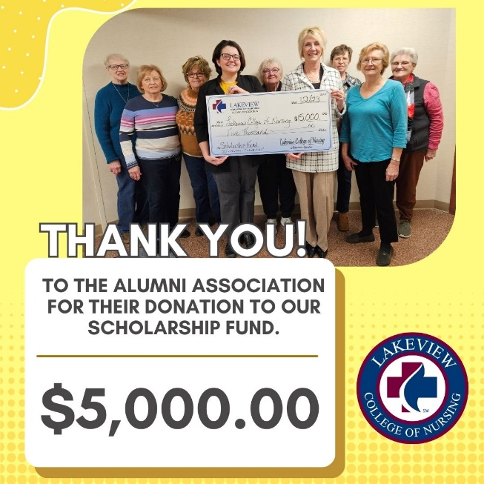
Karen Stefaniak RN, MSN, PhD, was awarded our Lakeview Outstanding Alumni 2024. Karen
continues in her career to perpetuate the knowledge, skills, and values instilled at Lakeview through educating nursing students. She is currently working at the University of Kentucky focusing on nursing leadership in MSN and DNP programs. Congratulations Karen!!!

I want to encourage everyone to start NOW thinking about who you want to nominate for our Lakeview Outstanding Alumni 2025. The Outstanding Alumni Award nominations are accepted year-round. Those received by February 1, 2025, will be reviewed for the 2025 Outstanding Alumni Award; those received after February 1 will be reviewed for the following year. The Outstanding Alumni Award will be presented at the May 9th, 2025, LCN commencement.

The Outstanding Alumni Award is presented to Lakeview Alumni who have demonstrated outstanding qualities in leadership and professionalism, nursing research or education, nursing administration, or have provided contributions to research service to humanity. The recipient must have distinguished themselves in nursing and exemplify the College's core values of adaptability, caring, excellence, integrity, and service. The recipient should also have a continued interest in and support for Lakeview College of Nursing.

Refer to specific outstanding alumni qualifications https://lcn.edu/outstanding_alumni/form. Link for submission form is https://lcn.edu/outstanding_alumni/form.
While I have you perusing the LCN web site, let me direct you to two more areas that we would like you to be aware of. #1 is the ALUMNI PROFILE. This page gives us an opportunity to reconnect with you. On this page, you can share your information and inspire others by sharing your professional accomplishments. The form for this is found at https://www.lcn.edu/AlumniProfile/form. #2 is ALUMNI REFERRALS. Do you know a student who may be interested in attending LCN? Please direct them to us through this online form: https://www.lcn.edu/AlumniReferral/form.
As we approach the month of June, we are looking forward to the 50-year luncheon for the Class of 1974 on June 8th … renewing old relationships and celebrating accomplishments … and a time to remember classmates who are no longer with us. Let's not forget the much coveted 50-year pin that they will receive. I'm sure everyone will enjoy their day! You can look for pictures of their day on the https://lcn.edu/alumni website. The Class of '74 will be sending their pictures and memories to Karlee Thomen, Administrative Assistant, at kthomen@lcn.edu. They will be uploaded to the LCN alumni page and be ready for sharing before the end of June. There is no deadline for submitting your pictures.

The Class of 1975 has already found all of their classmates in preparation for their celebration on June 21, 2025. Class of 1976 … it's time to find your people so everyone can make plans well in advance to attend your celebration.
This is the perfect spot to address the procedure for getting your 50-year pin if you are unable to be physically present at your 50-year luncheon. You will need to complete and return your annual dues form with the payment of dues for the current year – plus $60 to cover the cost of the pin. The alumni association will cover the cost of shipping. Just a note – 50-year pins cannot be ordered in advance of your actual anniversary year. This has been a little confusing … we understand. We absolutely want to make this happen for you!
This was in a previous letter but it bears repeating one more time – LCN has made us aware that they cannot change their database when there is a name change due to marriage or whatever without personal documentation from the respective alumni. Please contact LCN at alumni@lcn.edu or 217-709-0920 or 903 N. Logan, Danville, IL. 61832 to keep info current on contact/mailing lists.
The Lakeview Alumni Association wants to send a "shout out" of congratulations to the 2023-2024 graduates of Lakeview College of Nursing!!! We are excited for you and we will now have to live vicariously through your professional experiences and accomplishments! Make Lakeview proud!!!

The 2023 official first-time pass rate for LCN is 87%, above the state average of 85%. Students are currently taking the NCLEX-RN examination for the 2024 pass rate.
2023-2024 Graduates of Lakeview College of Nursing

December 2023 Graduates (18) |  |  |  | May 2024 Graduates (18)
Beatriz Amaya |  | Anthony Morgan |  | Angy Alvarado |  | Brayden Percival
Noredia Asia |  | Berich Mpoy |  | Chiquita Baker |  | Jackson Powell
Dakota Clayton |  | Shelby Myers |  | Roxanne Balag |  | Karlie Roberts
Cory Coffman |  | Molly Niemerg |  | Davis Coffey |  | Courtney Singleton
Maso Coon |  | Ashley Pascual |  | Jayda Davis |  | Shana Kim
Gabrielle Doss |  | Rancey Rouse |  | Kaitlyn Loewenstein |  | Angelina Thomas
Elijah Lamb |  | Camryn Studer |  | Emily Melecosky |  | Makynzie Wagner
Zachary Lensink |  | Malea Warner |  | Justin Munoz |  | Shanique Williams
Fallynne Moores |  | Elexus Williams |  | Gozi Okafor |  | Jonny Yap
Please refer to paragraph three in LCN President Sheila Mingee's letter on the next page for important update on LCN.
All alumni are invited to attend our local meetings – Fridays at 12:00 noon at the LCN, – a light lunch is provided by LCN. Dates of 2024/25 Alumni meetings are:
 | Dec 6, 2024 |  | May 23, 2025
 | Mar 7, 2025 |  | June 21, 2025 – Class of '75 50-year class celebration
 | April 25, 2025 |  | July 25, 2025 – wrap-up meeting

Respectfully,
Mary Mayfield
Update from Lakeview College of Nursing
Warm greetings from Lakeview College of Nursing!
As we journey through another year, I want to connect with you—our valued alumni. Your legacy and achievements continue to inspire and shape the future of our College. We invite you to share updates on your nursing journey, as we are always proud to highlight our alumni's success stories. Please complete the alumni profile form as mentioned in this newsletter.
Reflecting on the past year, I am incredibly proud of the progress and accomplishments of our faculty and students. Our College remains steadfast in its commitment to excellence in nursing education, preparing our students to become compassionate and skilled healthcare professionals. Lakeview College of Nursing maintains accreditation from the Higher Learning Commission and the Commission on Collegiate Nursing Education. The College is approved by the Illinois Board of Higher Education and the Illinois Department of Professional Regulation. Our state-of-the-art simulation lab, equipped with adult, pediatric, and infant simulators, provides our students with hands-on learning opportunities that closely mimic real-life scenarios. Additionally, we have introduced new scholarships and financial aid options to ensure students can access quality nursing education, regardless of their financial background.
As we look to the future, we recognize the evolving landscape of higher education, particularly the challenges for small, private, tuition-dependent, and nonprofit colleges like Lakeview College of Nursing. The challenges have been fueled by the pandemic, inflation pressures, labor issues, a shrinking pool of high school students nationwide, enrollment issues, and a transformation of higher education and nursing. Lakeview College of Nursing is not immune to these challenges. Therefore, after careful consideration and analysis, we have made the difficult decision to close the Charleston location, effective May 23, 2025. This strategic decision allows us to focus our efforts and resources on the main campus in Danville. This closure will not affect the progression of current Charleston students, all of whom are expected to complete the program by May 9, 2025. All educational records and transcripts will be maintained at the Danville campus. We remain committed to providing excellence in nursing education and look forward to continuing our mission at our Danville location.
Our current Strategic Plan focuses on six key goals:
- Provide a Quality Nursing Education Program
- Provide a System of Academic Support to Increase Retention, Success, and Satisfaction
- Foster a Diverse and Inclusive Campus
- Develop a Plan for Financial Sustainability
- Elevate Nursing as a Profession
- Enhance Employee Engagement and Communication

Your continued involvement and support are crucial as we work towards these goals. Whether through mentoring current students, encouraging prospective students to attend LCN, participating in events, or contributing to fundraising efforts, your engagement makes a significant difference. We will begin planning for the 2025-2028 Strategic Plan in the coming months and welcome feedback from our College Community and alumni.

Thank you for your unwavering support and dedication to Lakeview College of Nursing. Together, we can continue to build on our legacy of excellence and positively impact the future of nursing. Please do not hesitate to reach out if you have any questions.

Follow us on our Facebook page for college events, celebrations, and updates!

Warm regards,
Sheila Mingee
President
smingee@lcn.edu
Lakeview College of Nursing


LAKEVIEW ALUMNI
NEWSLETTER – 2024

1945 - 79 Years – all deceased

1946 – 78 Years –

1947 - 77 Years
Ruth (Newtson) Lounsberry – 4126 NW Blvd OW209, Davenport, Iowa 52806,
563-823-3636 home

1948 - 76 Years

1949 – 75 Years
Betty (Downs) Barkman – 3220 Independence Drive, Apt 118, Danville, IL. 61832. No phone

1950 – 74 Years

1951 - 73 Years
Joyce Perkins Keener - 3916 N Vermilion St. Apt 203 - Danville, IL. 61834, 217-260-1016 cell

1952 - 72 Years
Annabelle Breezely Clark - 1312 Fairway Dr, Danville, IL. 61832, 217-474-4046 cell,
217-442-5558 home, annabellclark80@yahoo.com
Jane Royalty Millis - 316 E. 14th ST, #228, (Autumn Fields) Danville, IL. 61832, 217-474-7233
Had pacemaker on 08-01-2023. Had reaction to medication and spent 38 days in OSF rehab in Urbana and then at Goldwater in Danville, and then to Autumn Fields Adult Living Center in Tilton. Next best place to home. Thanks to all who keep the Alumni going.
Joann Hulse Trobaugh - 155 W. Mertens Apt 305, Kankakee, IL. 60901 - 815-450-8851 cell –
815-432-8673 - cjtrobaugh51@outlook.com
I have moved to assisted living as of April 30, 2024 – at Heritage Woods of Watseka. I am making many new friends. Doing well.

1953 – 71 years
Gloria Hopkins Sundt Ferguson – 741 Park East Blvd, Ste. 413, Lafayette, IN. 47905
765-426-6980 cell, 765-474-8081 home
Marie Constantine "Connie" Gilbreath – 1205 Saratoga Dr., Danville, IL. 61832,
con33g@aol.com, 217-260-6656 cell, 217-442-7506 home
Thank you, Nancy for your loyal dedication. Congratulations to Mary Mayfield. I'm growing older, happy to still live alone and care for myself and my home and all the work that goes with it. Independent and loving it!!

1954 - 70 Years
Charlotte Joan Lewis Fleming – 316 E. 14th St. Apt 210, Tilton, IL. 61832-7611 –
217-274-8814 cell, Joanfleming03@gmail.com
Helen Lierman – 21 E. Owen, PO Box 413, Ridgefarm, IL. 61807
Nancy Beck Fishero – 342 Dry Branch Dr., Crawfordsville IN. 47933 – 765-362-4724 home
Class of '54 con't
Velma Hetrick Hobaugh – 7630 E. State Road 56, Orleans, IN 47452, 812-653-3089 cell,
hobaughv@gmail.com

1955 – 69 Years

1956 - 68 Years
Anita Bell - 521 Lee Ave, Terre Haute, IN 47804-1090 –
Note from Anita's husband, Don: Anita has dementia. She is at home on lots of medications. I have total care of her and that is okay – she is a very good patient. By the way, Anita likes cards – keep them coming.
Karen Mitchell Gulick Hettinger - 108 Hawthorn Dr, Villa Grove, IL. 61956, 217-832-3504 cell

1957 - 67 Years
Joyce Curry Elliott - 403 Wexford Ct, Bonaire, GA 31005 – elliottjoycem5@gmail.com
– 478-320-4536 cell – 478-923-5715 home
Hello to all my classmates of 1957. Congratulations to the grads 2024!
Marlene Bury Redenius – 1494 Derby Drive, Bourbonnais, IL 60914-9365
815-212-1694 cell, 815-935-8841 home – shop1936sale@gmail.com
I really miss the yearly banquet – but I know things change! I enjoyed spending some time with two of my classmates last fall – some things never change! Thanks to all who are working in the Alumni Association.

1958 - 66 Years
Col. Betty Bonwell Paps - 1 N Beacon Place #508, La Grange, IL. 60525 –
708-280-6414 cell - bpaps@aol.com
I am still traveling between my 3 homes: Florida in the winter for golf & bridge – Lake Geneva, WI. in the summer for golf & bridge – La Grange, IL in the fall to be with family. I keep busy with 3 book clubs and serve on 2 condo boards. Went on a River Cruise with my sister last November. We lost 2 sisters last summer. "Hello" to classmates of 1958.
Betty Boren Scharlach – 630 Woodview Dr., Tavares, FL 31778 – 352-455-7192 cell,
352-343-8261 home – BettyjScharlach@comcast.net
Congratulations to all the graduates! I am still using my RN as a Public Health nurse. I have reduced my hours. I work 7 hours on Monday and 4 hours on Friday. I have pretty easy jobs. I enter the legal immigrations regarding TB questions. They then go to the lab for the Quantification test – no more PPD's. My family is doing well and all 5 grandchildren are well and happy. I have been blessed.
M. Irene Phebus – 226 Freeport Dr., Sarasota, FL 34233-3366, 941-922-07656 cell
Would like all my classmates to contact me.
Rita Laflen Lewis - 12008 Club Commons Dr, Glen Allen, VA 23059,
RitaLLewis@comcast.net, 804-360-1872 home

1959 – 65 Years

1960 - 64 Years
M. Kay Howrey Herbold – 801 N. Logan, Room 323, Danville, IL. 61832 – 217-442-3154
Still at Accolade Nsg. Home. Several activities available. Never get bored. Food needs a lot of improvement. Memorials for deceased members are: Lifelong friends Freda Haworth Coate and Jeannie Reeves Nicholas; classmates Pat Sakotnik, Madeline Anderson, Linda Fleming, Kay Fourez Chacon, Marilyn Ping Neal, Marilyn Jarvis Darnell. I hope I didn't forget anyone. I donated last year for Marilyn Jarvis Darnell but got check in too late to be included.
Jeanette Kincade Porter - 1409 B Weathervane St., Champaign, IL. 61821 – 217-493-7291
Cell - Jport7291@gmail.com
Myrna Musson Roose - 315 E. Stark St. #217, Rockville, IN. 47872, 217-918-2548 cell

1961 - 63 Years
Deloris Hartle Lefton - 148 N Corporation Line Rd., Veedersburg, IN 47987 – 765-585-1563
cell, 765-294-2128 home – kimberlylefton@sbcglobal.net
Certainly miss getting together with all the nurses. Glad you are able to send letters of new though. My husband, Chuck, is undergoing chemo treatment for leukemia. Our twins will celebrate their birthdays in June. They will be 12 years old. They finished 6th grade. They are in 4-H, take dog obedience and sports; so, they have things to do. We just finished strawberry picking; did well this year. Have a garden at the farm that is doing well so far. Twins help keep weeds out.
Judith (Judy) Livengood Alder Howard - 4043 S. State Road 341, Kingman, IN. 47952,
765-397-3187 home - ms.judithelaine@gmail.com
Ron & I celebrated 31 years this January. Can't believe it's been that long, nor can I believe I've been out of nurses training 63 years and high school 66 years. Miss the banquet, see old friends and catching up.
Lois Green Roberts – 601 S. Summit St., Rossville IL 60963, 217-497-6731 cell,
lmroberts@frontline.com
Nancy Mae "Charlie" Brown Miller - 4660 N. Springwater Dr, Frankfort, IN. 46041 –
– 765-650-1635 cell- nmiller1963@yahoo.com
Ruth Veach Ciacco - 15449 Woodlawn East, S. Holland, IL. 60473, 708-339-6591 home

1962 - 62 Years
Wanda (Wendy) Means Lucarelli - 9709 Bianco Ter. Apt F, Des Plaines, IL. 60016

1963 - 61 Years
Eunice Bolen Mumm - 890 Co Rd 1900 E, Sidney, IL. 61877 – 9707 – 217-493-9000 cell
EMumm42@yahoo.com
Many years I was president of the LVMH Alumni Association president. I was happy to be a part of this school. This is an outstanding school. I have never missed a banquet.
Joyce Wilhoit Cornwell - 1900 Stanford Place, Edwardsville, IL. 62025,
cornwelljoyce@att.net – 618-920-3749 cell, 618-656-1331 home
Thank you for all your work with the Alumni Association
Linda Darlene Molt Sappenfield - 414 E Kyle, Ogden, IL. 61859, 217-417-1232 cell
Linda Peugh Myler - PO Box 467, Oakwood, IL. 61858 - TX 217-354-4716 home
Martha Ann Mackovec Gerrib - 221 McKinley St., Westville, IL. 61883 – 217-304-5082 cell, 217-267-7242 home – marthagerrib@gmail.com
Myrtle Eleanor (Mert) Wiatt Pitcock - 1581 Delegates Row, Crawfordsville, IN. 47933 –
765-365-5059 home
Sandra House Harris - 4009 Grand Mesa Drive, Montrose, CO. 81403 – 970-249-5466 home
ssharris269@yahoo.com
I am full time caregiver for my husband who is confined to a wheelchair and has multiple health issues. Would enjoy hearing from my classmates.
Sue (Julie) Rhodes O'Connor – 5680 Loch Broom Circle, Dublin "Muirfield", Ohio 43017 –
614-569-5525 Cell – Ggoconnor@Gmail.com
Sue O'Connor continues to enjoy retired life. This fall eight of my nine grandchildren are attending various colleges. Two juniors and one freshman at Miami University in Oxford, OH; one at Tiffin University on golf team; one at CCAD Art College in Columbus; one at Kent State and one at Transylvania College in Lexington, KY. Our youngest grandchild is entering high school this fall. Oops! A freshman starting this fall at John Carrol University in Cleveland, OH.

Class of '63 con't

Hello to any and all 1963 alumni. Congratulations to the 50-year class and Class of 2024. The nursing career has served me well and I pray the same for the 71 enrolled
at present. Sincerely, Sue O'Connor

1964 - 60 Years
Beverlie Richter Pippinger - 16718 N 740 E Rd, Oakwood, IL 61858, 217-354-4630 home
My husband had a heart attack Thanksgiving Day 2023 with resulting heart damage, heart failure with only 35% heart action before having 7-bypass surgery and aortic valve replacement at OSF Cardiovascular Surgery, Peoria, IL. Had excellent surgeon and care team and especially many prayers. His health has continued to improve after many weeks of recuperation, cardiac rehab (at Danville OSF) and treatment for A-fib. Also, want to say "Hi" to any of my 1964 classmates as this is our 60th graduation anniversary. Please feel free to get in touch with me if you wish. Maybe we can get together to celebrate.
Cheryl Foster Tuggle - 230 E 650 N, Attica, IN. 47918
Lois Smith DeVries – 4525 Chisholm Trl., Lafayette, IN. 47909 – 765-427-1293 cell
Loisdev1943@gmail.com
Marilynn Mary Marlow Humrichouse – 27697 270th Street, Eldora, IA 50627, 641-500-9015
cell, 641-497-5432 home, dhumric@heartofiowa.net
I am so sorry that I didn't make it to the 50th and miss having contact with my classmates from 1964. I lost my husband, Don, in 2022 and mis him very much. I am able to remain in the home he built for our family of 4 sons in 1979 with the help of the older sons who are still in Iowa. Blessings to all. Mary
Nancy Landsdown Cunningham - 26883 Shake Rag Rd, Danville, IL. 61834 –217-497-7643
I've been involved with this alumni newsletter and the previous banquet for several years and I cannot begin to explain the lump in my throat …the pride I feel, the thankfulness I feel toward the alumni members after opening the letters this year. You've been most gracious and giving and I'm "Lakeview Proud!" Thank you.
Norris Schlueter - 1883 Country Rd. 2500 E. St. Joseph, IL. 61873, 217-369-1973 cell
Nancy, thanks for all you do.
Sandra Longfellow Firebaugh – 4244 Red Barn Drive, Whitestown, IN. 46075 –
317-414-4525 cell, skfire@sbcglobal.net
Wanda Wilson Grygiel - 213 E 11th St., Danville, IL. 61832 – 217-417-2851 cell –
wgjg2009@att.net

1965 - 59 Years
Beverly Campbell Wyatt - 715 Sycamore Dr., Crawfordsville, IN. 47933 – 765-918-8550 cell -
bjcw@sbcglobal.net
Connie Bodine Hawthorne - 6702 W 1100 S, Covington, IN 47932 – 765-585-0280 cell,
765-793-4590 home - connieh44@yahoo.com
Donna Ricketts Jones - 21698 N 1400 East Rd., Danville, IL. 61834
Faith Prettyman Meece - 7355 Catboat Court, Fishers, IN 46038 -
Faithmce@sbcglobal.net – 217-898-3734 home, 317-813-8145 cell
As a family we are rejoicing the graduation from Carmel, IN High School of our 1st born grandson (out of 4), Ethan Kelson, what a blessing and a joy!!
Our Lakeview family of 1965 are saddened to hear of Mary Sue Ewing passing this year. As we get older, we will hear of more classmates leaving our "L.V. reunions" – and our "hearts will get heavier."

Class of '65 con't

Georgia Coslet Barnes - 1217 305th St, New Windsor, IL. 61465 – 309-667-2223 home -
georgiegirl12@nwctv.net –
Thank you, Nancy, for all you and the other girls do to keep the alumni going. Eunice will be missed for her enthusiasm. Sorry it's no longer feasible to have the luncheon where memories were made and relived.
Judith (Judy) Baker Cravens – 5225 Olivet Rd, Georgetown, IL. 61846 – 217-662-2375 home
Judith (Judy) Nicholas Petrus – 103 Lakeview Dr., Catlin, IL. 61819, 217-516-0272 cell,
217-427-5537 home, Petrusudy@gmail.com
Karen Frankino Stefaniak - 400 Bristol Rd., Lexington, KY. 40502 – 859-396-6193 cell
kastefoo@UKY.edu –
I continue to perpetuate the knowledge, skills and values instilled in us at Lakeview through educating nursing students. I currently work at the University of Kentucky focusing on nursing leadership in MSN and DNP programs.
The lakeview Alumni Association was proud to recognize Karen Stefanik RN. MSN, PhD as "Outstanding Alumni 2024" - This last comment added by Mary Mayfield, Pres. Lakeview Alumni Assoc. –
Mary Harvey Shroyer - 1437 Northridge Hills, Crawfordsville, IN. 47933 – 765-376-9040 cell,
mshroyer1944@gmail.com -
Norma Taylor - 5119 Pike Creek Blvd., Indianapolis, IN. 46254 – 317-341-5427 cell,
317-387-4591 home - taylorno@comcast.net
Sandra Sherer Seyfert - 1764 W 200 S, Covington, IN. 47932 – 217-474-3202 cell –
765-793-4256 home - skseyfert@gmail.com
Sandra Garmon Wilson - 9 Woodland Hills, Bismarck, IL. 61814 – 217-304-3061 cell,
217-759-7195, SKW122843@yahoo.com
Sharon Wilson Taylor – 2968 E. 1400 N. Rd., Windsor, IL 61957 – 217-254-2135 cell
Mary Ann Milliner Williams died September 13, 2023. She was in the Class of 1965.
I believe her husband was in the Class of 1966 – Ronald Wilson

1966 - 58 Years
E. Ann Landsdown Stevens – PO Box 401, 110 E. South St., Fairmount, IL. 61841
217-493-2318 cell – landsdown1@yahoo.com
Congratulations to our baby sister, Wanda Landsdown Ellis, Class of 1974 – 50-year recipient!!
Georgia Oxenford Horsley – PO Box 26, 102 6th St., Redmon, IL. 61949 – 217-251-2342 cell,
217-884-2342 home – georgiahorsky45@gmail.com
Janet Thompson Schwartz Heatherington – 9 Shady Ln., Danville, IL 61832 –
217-260-1006 cell – jehether@comcast.net
Jessie V. (Jennni) Burns Tyler – 9745 Fairway Dr., Foley, AL 36535 – 217-474-6175 cell –
Jenni-Tyler@aol.com
My husband, Larry Tyler, passed away 01-02-22, due to Covid. I still live in Foley, AL.
Linda (Lydia) Craycraft Allaway - 512 Sandusky St, Georgetown, IL. 61846 –

217-304-4897 cell - lindaallaway@att.net
Mary (Fran) Conner Reese – 1414 King St., Tilton, IL. 61833 – 217-474-9185 cell -
reesefran@gmail.com
Mary Lou Schroeder Varner – 901 S. 5th St., Watseka, IL. 60970 – 815-471-2002 cell,
815-432-4104 - mvarner23@gmail.com
Nancy Hamick Dubre - 617 Meadow Creek Dr., Tyler, TX 75703 – 903-3121406 cell, 903-
534-1403 home – nkdubre@suddenlink.net
Nancy J. Nixon Schwabauer – 2 Oak Brook Club Dr. B308, Oak Brook, IL. 60523
708-341-5987 cell – njschwabauer@gmail.com
Class of '66 con't

Nancy Schawitsch Godwin - 4419 W 650 S, Williamsport, IN. 47993 –765-337-3860 cell,
765-893-4201 home – nancygodwin42@yahoo.com
Sharon Hiser Bostwick – 3104 Brookstone Dr., Danville, IL. 61832 – 217-497-7003 cell
sharonbostwick@att.net
Wilma Hayse Postlewait - 4459 Reno Rd., Wellsville, KS 66092 – grandmawilma@live.com
– 913-963-6359 cell
Thank you, Nancy, and others who keep up with the activities of the alumni. Hello to my classmates from 1966. We traveled to Mackinac Island in the early fall. Stopped at Georgia's for the night. It's always good to spend time with my LVMH friends.

1967 - 57 Years
Donna Osborne Wilkerson - 3310 Fairway Drive, Danville, IL. 61832-1246
– 217-213-9963 cell, 217-442-8990 home - granny2tnt@gmail.com
Ella (Cookie) Yeley Bennett – 6781 Franklin Rd., Sumnee, IL 62466 – 618-707-5130 cell –
ebhb68@gmail.com
J. Renée Pinegar Estock - PO Box 313, Oakwood, IL. 61858 – 217-354-4976 home -
REstock@aol.com

1968 - 56 Years
Cheryl Pugh Stewart – 35710 N. 880 E. Rd., Rossville, IL 60963 – 217-274-4386 cell –
jcstewart928@gmail.com
Jayne Robinson – 401 Burwash Ave. Apt 351, Savoy, IL. 61874-9213 – 211-419-7745 cell –
robinsonjayne582@gmail.com
Julie Dumas Griffin – 13115 Lester Dr., St. Louis, Mo 63138 – 314-791-8083 cell –
RNJGRIFFY1947@gmail.com
June Krug Doyle – 331 Westside Ave #7, Mukwonago, WI 53149 – 608-576-3695 cell
tjdoyle98@msn.com –
Luanne Price Kees - PO Box 288, Catlin, IL. 61817 – 217-260-2653 – ljkees82@aol.com
Margaret (Midge) Howie VanCleave - PO Box 578, 425 S. Seymour St, Oakwood, IL 61858 –
– 217-260-4149 cell, 217-354-4149 (home) - danmidge@comcat.net
Maureen Sue Linn Scharlach – 760 Amster Green Dr., Sandy Springs, GA 30350
404-918-8370 cell, 770-394-8370 home - sueschattauer@me.com
Patricia "Pat" Peshoff - 102 Pecan Grove Apt 409, Houston, TX 77077 – 832-493-6154 cell,
832-328-0609 home - peshoffp@gmail.com
Sharon R. Morris Michaelson - 8562 Wyoming Club Dr, Cincinnati, OH 45215 –
513-769-5571 home - moegge8562@gmail.com

1969 - 55 Years
Teresa (Terry) Lighty Harmless - 103 W. First St, PO Box 326, Hillsboro, IN. 47949 –
765-366-0034 cell - leharm@gmail.com
Still enjoying retirement after 40 years at Crawfordsville, IN. hospital. Winter in Florida with husband, Larry.

1970 - 54 Years
Brenda "Sue" Gard Sewell - 2148 University Ct, Clearwater, FL. 33764 – 727-709-2128 cell -
USFSEWELL5@yahoo.com ***new info
Enjoying retirement but stay very busy helping others. Happy 54th anniversary to my class from 1970!!

Class of '70 con't

Diane Hovelin Acton – 23694 N. 900 E. Rd., Collison, IL 61831 – 217-497-2776 cell,
217-776-2633 home – dacton11@hughes.net
Nursing career was devoted to neonatal nursing and then geriatrics. Worked for State of IL. Division of Long-Term Care for 25 years before retirement. We have 3 children with families, 6 grandchildren, and 1 great grandchild, second one coming in July. Our youngest daughter, Katie, is a LVCN alum of 2001, and continued to receive her master's degree at Indiana University. She is now a Nurse Practitioner working at Methodist in Indianapolis. Lakeview provided great educations and wonderful experiences for both of us.
Karen Pelg Crocker – 20 Highlander Trl. SW, Rome, GA 30165 – 706-936-0058 cell –
Karen@karencrocker.com
At 75 years old, I'm still working. My journey – NICU, ICU, ER, Supv. of UpJohn Health Care and Supv. of visiting nurses @ the same time. First born had bilateral vocal cord paralysis and had a trach'. I let my license lapse and did private duty with him. We had 2 more sons. Both had medical problems; so, I was thankful that I was a nurse. God healed them. I also got a degree in education at Trinity College in FL. where I had met my husband. After about 30 tests and 300 some hours of working at a hospital, I got my RN back. Worked in outpatient pre-op, hospice, Director of Health and Wellness at an assisted living and now I work for Home Instead. We have 6 grandchildren. It was wonderful seeing some of you when I was in town!! We were so blessed having training at Lakeview! You wouldn't believe some of the nurses that I've seen!
Linda "Harv" Harvey Lutz – 518 Crestview Dr. S, Saint Paul, MN 55119, 612-201-9217 cell –
linlutz@msn.com
Dale & I are happily retired. We love spending time with our son, Christopher, his wife, Jill, and our grandsons, Jake and Max. We see our daughter, Laura, and her partner, John, as often as possible. Now that we have time we are traveling more. We currently have a European cruise and a week in New Orleans on the calendar. Life is good.
Clas of '70 cn't
Mary Lee Key Mayfield - 1003 Hillside Drive, Danville, IL. 61832 – 217-260-1845 cell
mary41548@comcast.net
It's been a busy year, but I like it that way. We managed to work in one small group lunch while Karen Pelg Crocker was home to visit her mother … we need to do more.
If any of the Class of '70 come to the Danville area – or even close – let me know and we will plan a lunch date for/with you.
I was elected President of the Lakeview Alumni Association last year. A new and challenging experience, but exciting. There are so many changes and things to navigate for the benefit of all of our alumni. I will give it my best.
Michael Boorde – 1101 Perrysville Ae., Georgetown, IL. 61846 – 217-370-6258 cell,
217-662-6812 home – boorde@hotmail.com
Susan "Nuch" Nuccio McNeill – 1003 Post Oak Rd., Charleston, IL. 61920 – 217-549-2772
cell - Lelandmcneill@hotmail.com

1971 - 53 Years
Dwight Bushue - 8046 Westcott Lane, Tumwater, WA. 98501 – 360-789-5529 cell –
BUSHUEDARNP@comcast.net
Remain very proud of Lakeview. Keep up the good work.
Sue Philpott – 4918 W. Didion Dr., Tucson, AZ 85742 – 520-904-3275 cell
4918SuePhil@gmail.com

1972 - 52 Years
Marilyn Taylor Moore - 3420 Evans Ave, Cheyenne, Wy 82001; 307-477-3420 cell,
307-638-2221 home – Moore82001@gmail.com
I've been retired for a year and enjoying my free time. I did help out during the legislative session in Feb. at the Capitol. It was fun to work every day for a little while.
I would love to hear from my classmates of 1972.
Sandra (Sandy) Rader Howard – PO Box 213, West Lebanon, IN. 47991

1973 - 51 Years
Barbara (Barb) Kroll Kotcher – 97 E. 33rd Rd., Peru, IL. 61354
Carla Williams Walge - 212 Denvale Dr, Danville, IL. 61832 – 217-474-9191 cell
cjwalge@comcast.net
I want to thank the alumni for the lunch and 50-year pin provided for the Class of '73 last June. It was very much appreciated.
Chris McBride Cade - 814 E Chestnut St, Hoopeston, IL. 60942 – 217-474-7319 cell –
christicade787@gmail.com
Diane Falconio Shapuras - 200 Country Lane, Westville, IL. 61883, 217-474-2820 cell,
217-267-2820 home, nurseiron@aol.com
Jeanne Jenkins Fowler – 2932 S. 200 W., Tilton, IL. 46072 – 765-432-7100 cell –
tcfowler@hotmail.com
Kathy Smith - 1136 Englewood Dr, Rantoul, IL. 61866 – 217-372-6049
kathyrantoul@yahoo.com
Olivia Olmstead Humphreys – 420 Lakemont Ave, Danville, IL. 61832 – 217-497-7337 cell –
divia.humphreys@att.net
Also, Class of 1991 BSN

1974 - 50 Years
Carole Sproll Bond – 13856 E. 3785 N. Rd., Hoopeston, IL. 60942 – 815-383-4672 cell
cjbond99@gmail.com
I've been married 51 years to my husband, Tom; have 2 daughters and 2 granddaughters. I retired in Jan '22 from Carle HRHC. During my career I worked at IMH 3 years on M/S and 40 years @ Carle Hoopeston, 4 years M/S, 30 years in surgery which I loved. Finished my career in the Quality Dept – Infection Prevention Pt. Safety Quality and Employee Health. You wear a lot of hats in a small hospital!
Since retirement I've been enjoying book club, Bible study, gardening, lunching with friends and supporting our daughters and granddaughters in their activities. In Jan. I started subbing as a Para-Professional at the local grade school and really enjoy it. I am looking forward to seeing and catching up with classmates at the Alumni luncheon in June – 50 years!!
Christine Franklin Vanderpoortin – 22855 County Rd., 12 South, Foley, AL 36535 –
601-259-0670 cell – christv52@gmail.com
Deorah Lowry Walton
Ellen Jones Carney – Sr. Ellizabeth Mary ERM - 1718 Lambert St., Indianapolis, IN 46221 –
317-777-2386 cell – ellen.carney@me.com
Harriett Strain – 2642 Agate Meadows, White City, AR 97503 – 951-287-9218 cell –
grandmahat14@gmail.com
Unable to attend luncheon. Love the scholarship participation! I would love to get in touch with Bonnie Emery, Class of 1965 if you have a contact.

Class of '74 con't

Julie Price Shank - 3701 Leadville Dr., Austin, TX 78749 – 512-923-2595 cell –
jshank22@gmail.com
Unfortunately, because of health and family responsibilities, I cannot come to the
reunion. I would love to be there. Julie
Karren Emery Turner – 1009 Broadmoor Dr., Champaign, IL. 61820 – 217-597-1658 cell –
msturner971@gmail.com
Hello to LVMH Class of 1974 and LCN Class of 1995!!! I will be happy to see everyone again at the Lakeview Alumni Class of 1974!!! It seems like everything has gone faster than I thought! I retired in 2019 to become a grandma for my 2 grandchildren – Harper is 7 years old now and Spencer is 5 years old. They kept me busy with school and taking them to football, soccer, tennis, and golfing. Hope to see you at our 50th reunion!!!!
Linda Youhas Abbott – 1020 Orchard Dr., Covington, IN. 47932 – 217-474-2453 cell -
linda.katcher@gmail.com
Retired. Volunteering with the American Red Cross as a disaster worker, shelter supervisor and starting reunification. If you enjoy helping others, think about the Red Cross.
Marjory "Marge" Hutmacher Lancaster - 11255 E. Maywood Ct, Effingham, IL. 62401 –
- 217-259-4764 cell - tmlancaster05@gmail.com
It is nice of you to have a 50th luncheon for us!!!!
Marth Lockett Martin – 3013 Flessner Rd., Urbana, IL. 61820 – 651-592-4954 cell –
Rosenbery1952@yahoo.com
My last name was Lockett at graduation. I retired from Hennepin County Medical Center in 2017 where I was a float nurse in clinics; having been trained in about 30 different primary care and specialty clinics. It was my favorite job in all my career. I had planned to work longer, unfortunately, a fairly significant concussion in April of 2017 and a bout with right hip arthritis led to my decision to retire November 1, 2017. At the end of November 2017 I returned to Urbana, Illinois where I grew up. Since then, I have renewed friendships and made a lot of new friends at Urbana Senior Club & Quest UMC Church. My daughter, Karren is still in Minnesota; and granddaughters Kaisha & Meghan are in Minnesota and Colorado. I plan to attend the event for Class of 1974 @ Jocko's on June 8, 2024 – no guest. Thank you to alumni officers for all you do to make this event possible. Sincerely, Marty Martin
Mary Ritter - 37280 N 1900 E Rd, Rossville, IL. 60963 - 217-474-5024 cell -
mbritter@gmail.com
Nancy Wise Conrad – 24606 N. 1785 E. Rd., Bismarck, IL. 61814 – 217-474-3657 cell –
rnconrad75@yahoo.com
I retired from the VA in 2014 after 40 years. I enjoy traveling and quilting, spending time with friends and family.
Priscilla Barkman Phelps – 14617 Baltic Dr., Danville, IL 61834 – 217-474-5240 cell,
217-446-2161 home – pphelps811@comcast.net
Wanda Landsdown Ellis - 1695 S 1100 W, West Lebanon, IN. 47991- 217-304-4365 cell
nwellis75@yahoo.com

1975 - 49 Years
Christine Holycross – 707 E. 9th ST., Georgetown, IL. 61846 – 217-304-3862 cell
Holygwc@aol.com –
Debora Sue Cook - 671 Country Rd 2175 N, Champaign, IL 61822 - 217-649-7799 cell
Tasdsc@yahoo.com
Class of '75 con't

Debora Weicherding Nygren - 1909 N. Whitcomb Ave, Indianapolis, IN 46224 –
317-809-8242 cell - dnygren@sbcglobal.net
I continue to practice in family practice and psychiatry with an emphasis in addition medication. I continue to volunteer at several clinics around Indianapolis. I am looking forward to our 50-year reunion.
Debra G. Armantrout Howser – 877 S.E. Y Hwy, Knob Nester, MO. 65336 – 660-441-2762
cell - dghowser@yahoo.com –
Fred Hill – 319 Deer Lane, Pamplin, VA 23958 – 934-574-5134 home –
hillfcstory@centurylink.net
Judy Evans/Carpenter Pendleton – 28 Crystal LN., Bismarck, IL 61814 – 217-260-0524 cell,
217-431-0524 home - Judy.pendleton@comcast.net
Kathy Chesrown – 2708 Wey Hill Ct., Augusta, GA 30909 – 803-553-8466 cell –
kathyarn75@gmail.com
Kathyrn Ann Williamson England – 303 S. Wilson St., Palestine, IL. 62451-1134 –
812-430-9201 cell – englandk23@gmail.com – RN, BSN, MSN
RN Class of '75, University of Evansville BSN Class of 1983 and MSN Class of 1985
Married Fred in 1983 – 2 children, son in 1987, daughter in 1998
LuAnn Lindgren Armantrout – 3036 E. 2450 N. Rd., Donovan, IL 60931 – 815-263-1233 cell
- luarmantrout@yahoo.com
Nancy Inman – 427 E. Winter Ave., Danville, IL. 61832 – 217-304-7214 cell –
N.INMAN@comcast.net
Sandra (Sandy) Morrison Kizer - 22019 Denmark Rd, Danville, IL. 61834 - 217-474-4351
cell SK – 217-474-4352 Cell LK – KMKIZER@gmail.com
Also, RN Class of '75, BSN Class of 1992.
Have grandson Tristen. He and Jenna have great granddaughter, Taya, and twin grandsons Jackson and Jensen. Granddaughter, Krislyn, age 18, is graduating from Bismarck (BHRA) High School. Granddaughter, Kaylynn, age 14, is having 8th grade recognition at Bismarck Jr. High. Granddaughter, Norah, age 10, is currently in Bloomington grade school. She just won 1st place at an art contest by Miller Park Zoo Recycled Art Sculpture. She made a large Flamingo.
Larry and I are enjoying retirement. The "old" ER gang got together to visit with Dr. Malhotra and Rosie. They traveled up from Florida for Dr. Sekar's retirement party. This was terrific to see them again. Still have to refer to him as Flic-a-bic. He just smiled a big grin.

1976 - 48 Years
Ann Light Wagle - 25950 N 1930 E Rd, Bismarck, IL 61814 – annwagle@gmail.com
Martha Rutan Jones - 2906 Jones Rd, Danville, IL. 61834 – 217-918-3462 cell –
mjjrn2@yahoo.com
Sherrie Atwood Shoemaker

1977 - 47 Years
Elizabeth (Beth) Webb Garrett - 4095 Brown St. PO Box 31, Kansas, IL. 61933 –
217-246-0161 - beth_rn_sarabush@yahoo.com
Susan (Susie) Gleichman Larrance - 201 Plum St, Georgetown, IL. 61846 –
– 217-799-4234 cell, 217-552-2632 home - Larrencefam@gmail.com

1978 - 46 Years
Bess Hecker Huls – 22735 N. 1450 East Rd., Danville, IL. 61834 – 217-497-0425 cell
Bess222@comcast.net
Diane Nibeck Nibeck-Smith – 10635 Midnight Dr., Indianapolis, IN 46239 – 317-627-8055
cell - dianeni@aol.com
Glenna Haacke Shank - 13279N. Central School LN., Lewistown, IL 61542 – 309-621-5147 cell
Kathleen Hargan Estock – 26 Santa Fe Drive, Auburn, IL 62615

1979 - 45 Years
Sandra Dumont Kaiser – 24 Glacier Drive, North Kingston, RI 02852 – 401-787-8447
cell – 401-884-9018 home - SKRN757@gmail.com
Jill Zollar - 2600 46th St SW, Naples, FL. 34116 – 239-280-6516 cell, 239-353-1642 home –
jzollar1@comcast.net –

1980 – 44 Years

1981 – 43 years
Eileen Kinson – 439 Tanasi Hwy, Loudon, IN 3774 – 865-408-9033 home –
Eikibo@charter.net
Vickie Anders – 285 N. Porte Dr, Highland, IL. 62249 –217-840-6937 cell -
JVA1534@comcast.net - Also, BSN Class of 1997

1982 – 42 years
Deidre (Dee) Lang Tyler – 9833 Elizabeth Lake Rd., White Lake, MI 48386 – 248-379-0188
cell – deetyler@comcast.net
JoAnn Roberts Henry – 507 S. Main St., Kirklin, IN 46050 – 765-659-8450 cell –
jodyann476@gmail.com

1983 – 41 years
Connie Schroeder – 405 E. Lyle St, Milford, IL. 60953 – also BSN Class of '91
815-922-2046 – cschroeder52@gmail.com

1984 – 40 years
Jennifer (Jenny) Trimmell – 926 Cunningham Ave, Danville, IL 61832 –217-260-3515 cell
J.Trimmell@comcast.net – also LCN BSN Class of '97

1985 – 39 Years

1986 – 38 Years

1987 – 37 years
Deborah (Debbie) Bransky Markley – 2645 Riverside Dr., Apt #1116, Trenton, MI 48183 –
– 727-465-4185 cell – debmellow@yahoo.com

1988 – 36 Years

1989 – 35 Years



LAKEVIEW COLLEGE OF NURSING
1990 - 34 Years
Lisa Piatt Edenburn - 1764 US Highway 136, Penfield, IL. 61862 – 217-304-7491 cell
lisaedenburn@gmail.com

1991- 33 years
Connie Schroeder – 405 E. Lyle St, Milford, IL. 60953 - 815-922-2046 –
cschroeder52@gmail.com - LVMH Class of ’83 – LCN BSN ‘91
Olivia Olmstead Humphreys – 420 Lakemont Ave, Danville, IL. 61832 – 217-497-7337 cell –
divia.humphreys@att.net – LVMH Class of ’73 – LCN BSN Class of 1991

1992 - 32 Years
Sandra (Sandy) Morrison Kizer - 22019 Denmark Rd, Danville, IL. 61834 - 217-474-4351 cell
– 217-474-4352 Cell LK – KMKIZER@gmail.com

1993 - 31 Years

1994 – 30 Years

1995 – 29 Years

1996 - 28 Years
Lea Ann Cunningham Brinkley - 276 Sassafras, Danville, IN 46122

1997 - 27 Years
Constance (Connnie) Reynolds - 2022 Liberty St, Tilton, IL 61833 – 217-516-2296 cell –
217-431-6087 home - creynolds342@gmail.com
Jennifer (Jenny) Trimmell – 926 Cunningham Ave, Danville, IL. 61832 – 217-260-3515 cell
J.Trimmell@comcast.net – also LVMN Class of 1984
I am retired form nursing but continue to maintain an active license. Being retired it is challenging to maintain C.E.U.s to renew license. It would be nice if LCN or the alumni assoc. could provide some C.E.U.s, especially the ones mandated by the state.
Vickie Anders – 285 N. Porte Dr, Highland, IL. 62249 –217-840-6937 cell -
JVA1534@comcast.net - RN Class of ’81 - BSN Class of 1997

1999 – 26 Years thru 2004 – 20 Years

2005 – 19 years

2006 – 18 Years thru 2009 – 15 Years

2010 - 14 years thru 2011 – 13 years

2012 - 12 Years
Linda Barselow - 607 Brentwood St, Tilton, IL. 61833 – 217-260-6520 cell –
linda.Barselow@yahoo.com

2013 – 11 Years thru 2023 – 1 Year

2024 / 2025 LAKEVIEW ALUMNI MEETING DATES

2024 | Dec | 6th | 1st Fri.
2025 | March | 7th | 1st Fri.
2025 | April | 25th | 4th Fri
2025 | May | 23rd | 4th Fri
2025 | June | 21st | 4th Fri | 50-year Class of '75
2025 | July | 25th | 4th Fri

LAKEVIEW ALUMNI ASSOCIATION

Officers for the past year 2024-2025
President - | Mary Mayfield | - Class of '70
Vice-President - | Nancy Cunningham | - Class of '64
Secretary - | Beverlie Pippenger | - Class of '64
Treasurer - | Sandy Seyfert | - Class of '65
Board Member - | Ann Stevens | - Class of '66
Board Member - | Darlene Sappenfield | - Class of '63
Board Member - | Eunice Mumm | - Class of '63
Alum rep on LCN board | Nancy Cunningham | - Class of '64

MAKE A DONATION

You can help future nurses by donating to our Alumni Scholarship Fund! Click the "Pay Here: button at www.lcn.edu or mail your check to Lakeview College of Nursing at 903 N. Logan Avenue, Danville, IL 61832. Please indicate "Alumni Scholarship" in the memo field of your check or the description field if you are making an online donation.


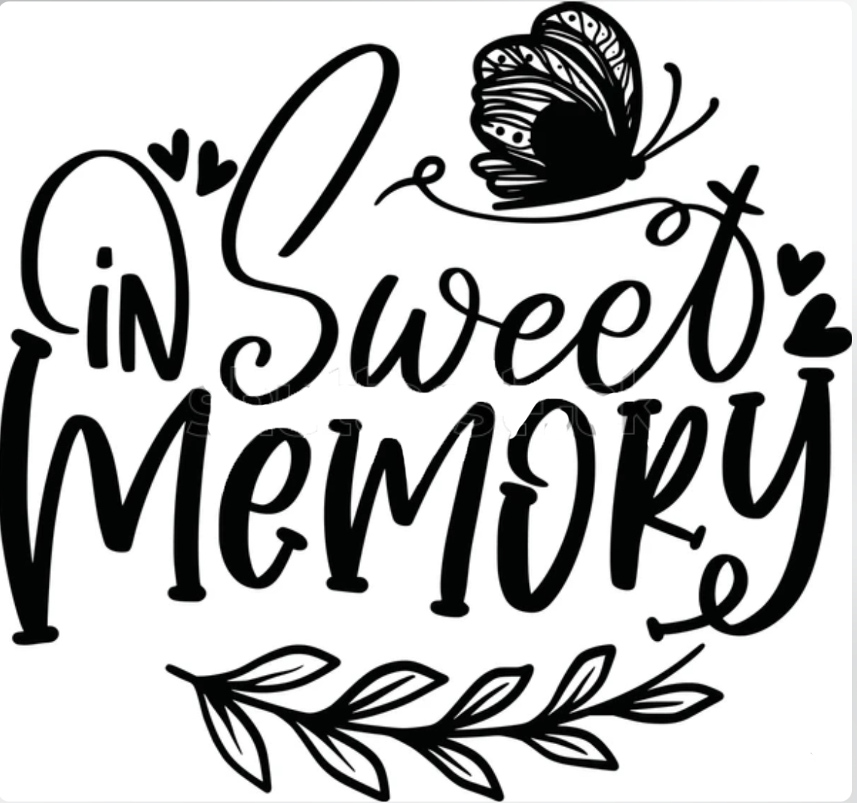

DONATIONS
in memory of deceased alumni

Class of | In memory of | Name of donor | Class of  - or relationship
‘47 | Dorothy Cornett Jones | Ellen Carney | ’74 mother
‘47 | Francis Burton | James Burton | Husband
‘47 | Joyce Atchison | Sandy Firebaugh | Friend
‘52 | Pat McConnell McCay | Jane Royalty Millis | Class of ‘52
‘54 | Mary Henson |  | Family
 | Dr. J. L. Gulick | Karen Hettinger | ‘56
‘56 | JoAnn Boren | Betty Boren Scharlach | ‘58
‘58 | Doloris Stewart Copsy | Irene Phebus | ‘58
‘60’s | Freda Howard Coate – Jeannie Reeves  Pat Sakotnik – Madeline Anderson – Linda Flemming – Kay Fourez Chacon - Marilyn Ping Neal – Marilyn Darnell | Kay Howery Herbold | ‘60
‘60 | Marilyn Darnell | Myrna Mussonn Roose | ‘60
‘61 | Emma Jean Geralds | Judith Livengood Howard | ‘61
‘61 | Sally Galyen Grubb | Ruth Veach Cracco | ‘61
‘64 | Sandy Araujo – Carol Saylor – Barb Snapp – Nikki Dowling | Beverlie Richter Pippinger | ‘64
‘65 | Mary Zumwalt Ewing | Faith Prettyman Meece | ‘65
‘65 | Mary Zumwalt Ewing | Joseph Ewing | Husband Joseph
‘65 | Mary Zumwalt Ewing  Mary Milner Williams | Georgia Coslet Barnes | ‘65
‘66 | Judy Winkler | Fran Conner Reese | ‘66
‘66 | Judy Winkler | Linda Craycraft Allaway | ‘66
‘67 | Helen Dotson | Renee Estock | ‘67
‘67 | Helen Johnson Dodson – Carolyn Clark Garrett | Donna Osborne Wilkerson | ‘67
‘68 | Kathy Shonkwiler Grittin | June Doyle | ‘68
‘70 | Diane Gundrum Carey | Linda Harvey Lutz | ‘70
‘70 | Diane Gundrum Carey | Mary Lee Mayfield | ‘70
‘70 | Diane Gundrum Carey | Susan Nuccio McNeill | ‘70
’71 | Stephanie Dumas | Julie Dumas Griffith | ‘68
‘74 | Sally Gay | Martha Lockett Martin | ‘74
‘74 | Sally Gay, Susan Blumhardt Yelken & Kathy Arthion Flexser | Nancy Wise Conrad | ‘74
‘82 | Cheri & Teri Fitzgerald | Deidre Lang Tyler | ‘82
DONATIONS
General & Scholarship

Name of donor Name of donor

Ruth Newtson Loundsberry | Class of: | ‘47
Betty Downs Barkman | Class of: | ‘49
Joyce Perkins Keener | Class of: | ‘51
Annabell Breezely Clark | Class of | ‘52
Jane Royalty Millis | Class of: | ‘52
Marie Connie Gilbreath | Class of: | ‘53
Velma Hetrick Hobaugh | Class of: | ‘54
Anita Bell | Class of: | ‘56
Karen Mitchell Hettinger | Class of: | ‘56
Joyce Curry Elliott | Class of: | ‘57
Marlene Bury Redenius | Class of: | ‘57
Betty Bonnwell Pops | Class of: | ‘58
Betty Boren Scharlach | Class of: | ‘58
Rita Laflin Lewis | Class of: | ‘58
Myrna Musson Roose | Class of: | ‘60
Judith Livengood Howard | Class of: | ‘61
Lois Green Roberts | Class of: | ‘61
Nancy Brown Miller | Class of: | ‘61
Ruth Veach Cracco | Class of: | ‘61
Darlene Molt Sappenfield | Class of: | ‘63
Eunice Mumm | Class of: | ‘63
Joyce Wilhoit Cornwell | Class of: | ‘63
Martha Mackovic Gerrib | Class of: | ‘63
Myrtle Wiatt Pitcock | Class of: | ‘63
Sandra House Harris | Class of: | ‘63
Sue O’Conner | Class of: | ‘63
Cheryl Foster Tuggle | Class of: | ‘64
Mary Marlow Humrichouse | Class of: | ‘64
Nancy Landsdown Cunningham | Class of: | ‘64
Donna Ricketts Jones | Class of: | ‘65
Judith Nicholas Petrus | Class of: | ‘65
Karen Frankino Stefaniak | Class of: | ‘65
Norma Taylor | Class of: | ‘65
Sandy Scherer Seyfert | Class of: | ‘65
Sandra Garmon Wilson | Class of: | ‘65
Sharon Wilson Taylor | Class of: | ‘65
E. Ann Landsdown Stevens | Class of: | ‘66
Janet Hetherington | Class of: | ‘66
Jenni Tyler | Class of: | ‘66
Nancy Hamick Dubre | Class of: | ‘66
Nancy Schawitsch Godwin | Class of: | ‘66
Nancy Nixon Schwabauer | Class of: | ‘66
Sharon Hiser Bostwick | Class of: | ‘66
Wilma Hayse Postlewait | Class of: | ‘66
Cheryl Pugh Stewart | Class of: | ‘68
Georgia Coslet | Class of: | ‘68
Jayne Robinson | Class of: | ‘68
Luanne Price Kees | Class of: | ‘68
Pat Pishoff | Class of: | ‘68
Sharon Morris Michaelson | Class of: | ‘68
Maureen Sue Linn Schattauer | Class of: | ‘68
Theresa Lighty Harmless | Class of: | ‘69
Brenda “Sue” Gard Sewell | Class of: | ‘70
Diane Hoveln Acton | Class of: | ‘70
Linda Harvey Lutz | Class of: | ‘70
Mary Lee Key Mayfield | Class of: | ‘70
Michael Boorde | Class of: | ‘70
Susan Nuccio McNeill | Class of: | ‘70
Dwight Bushue | Class of: | ‘71
Sandy Rader Howard | Class of: | ‘72
Barbara Kroll Kotecki | Class of: | ‘73
Carla Williams Walge | Class of: | ‘73
Christi McBride Cade | Class of: | ‘73
Diane Falconio Shapuras | Class of: | ‘73
Kathy Smith | Class of: | ‘73
Olivia Humphreys | Class of: | ‘73
Deborah Lowry Walton | Class of: | ‘74
Carol Sproll Bond | Class of: | ‘74
Harriett Strain | Class of: | ‘74
Julie Shank | Class of: | ‘74
Karren Emery Turner | Class of: | ‘74
Linda Youhas Abbott | Class of: | ‘74
Marjorie Lancaster | Class of: | ‘74
Mary Ritter | Class of: | ‘74
Nancy Conrad | Class of: | ‘74
Pricilla Barkman Phelps | Class of: | ‘74
Wanda Landsdown Ellis | Class of: | ‘74
Debra Armantrout Howser | Class of: | ‘75
LuAnn Lindgren Armantrout | Class of: | ‘75
Nancy Inman | Class of: | ‘75
Sandra Morrison Kizer | Class of: | ‘75
Martha Rutan Jones | Class of: | ‘76
Elizabeth Webb Garrett | Class of: | ‘77
Susan Gleichman Larrance | Class of: | ‘77
Bess Huls | Class of: | ‘78
Jill Zollar | Class of: | ‘79
Sandra Dumont Kaiser | Class of: | ‘79
Vickie Anders | Class of: | ‘81/’97
JoAnn Roberts Henry | Class of: | ‘82
Jennifer Trimmell | Class of: | ‘84/97
Deborah Bransky Markley | Class of: | ‘87
Lisa Piatt Edenburn | Class of: | ‘90
Lea Ann Cunningham Brinkley | Class of: | ‘96
Linda Barselow | Class of: | 2012

